Functions

Part 1
- Write a program that gives simple math quizzes.
- The program should display two random numbers.

  - The link below is to a Youtube video that explains how to generate random number in Python

https://www.youtube.com/shorts/KaK_U1Acc8c

- An example of how the numbers would be displayed is shown below
247
+ 129
- The program should allow the user to enter the answer.
- If the answer is correct, a message of congratulations should be displayed.
- If the answer is incorrect, a message showing the correct answer should be displayed.
Part 2
Make the program a menu driven program. Meaning the program is to display a list of options to the user to choose from .list of options is show below

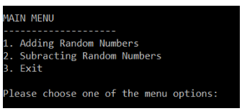
Add another function to the program that subtracts the generated random numbers. When program is exectued, the MENU is to be displayed and user enters their choice. If user enter "1" the program is to add the numbers and asks user to guess what they add to. If "2" is entered , the program dispalys the numbers but asks enter the remainder of the subtraction and REMEMBER, program only terminates if user enters 3.
Hint:
- When/if user enters 1, the program is to execute a function(add_function()) that generates the numbers , adds them , ask user for enter and display results.
- When/if user enters 2, the program is to execute a function(subtract_function()) that generates the numbers , subtracts them , ask user for enter and display results.
- If/when the user enters 3, the program is to terminate.
- When/if user guesses the right number, congratulate them and display the menu again to give them the option to play again
IMPORTANT : Program only terminates if user enters 3

